TMD-800

www.teyman.com
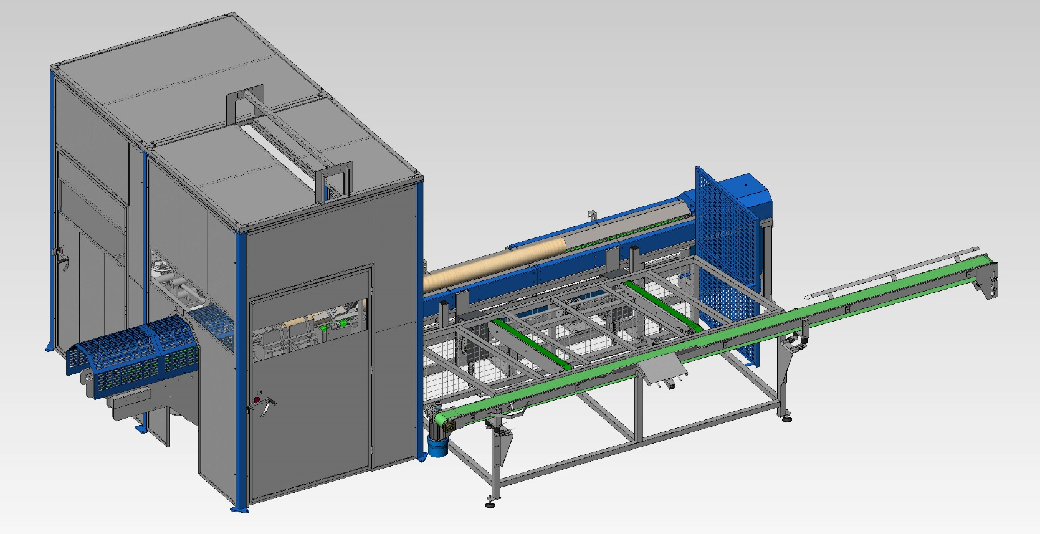

CUTTING SAW

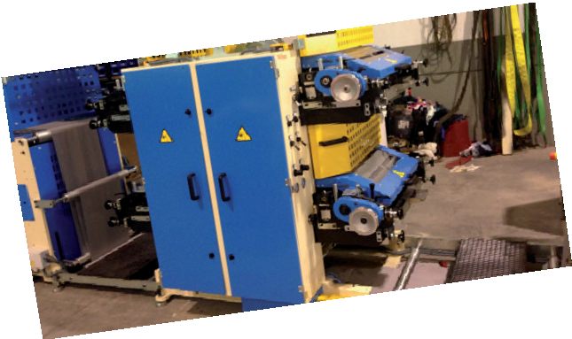
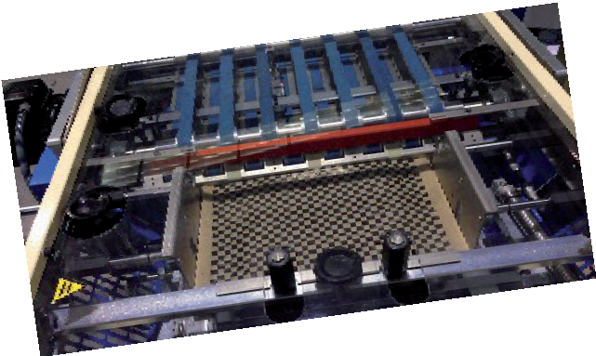
TMD-800

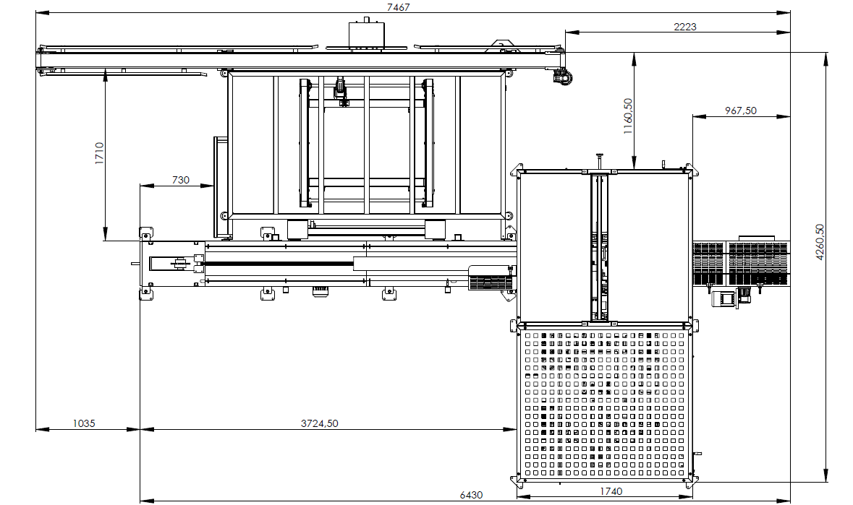

DATI TECNICI
Material: Fabric
Weight: 5,800 kg
Maximum production Industrial Coil and Chamine: (depends on the product to be cut) 20 cuts/minute.
Maximum production Industrial Hygiene: (depends on the product to be cut) 45 cuts/minute.
Installed power / Voltage: 12.5 Kw / 380 V.a.c.
Machine structure color: GREY RAL 7035.
Mudguard color: BLUE RAL 5024.
Machine/manual language Spanish.
CARATTERISTICHE
Disc roller advancement and cutting table.
Roll accumulator with stainless steel plate
Automatic accumulator input belt.
Ø810 and Ø1000 mm discs can be mounted
Installed power 12.5 Kw.
EEC regulations.

FORMATO Y DIMENSIONES

Width x Depth: 7,467 mm x 4260.50 mm

Height: 3,125 mm

ACCESSORI OPZIONALI
Available jaw sizes:
- ø110 a ø130
- ø150 a ø170
- ø170 a ø200
- ø200 a ø230
- ø240 a ø270
- ø260 a ø290
- ø290 a ø320
- ø320 a ø350



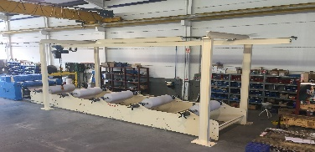
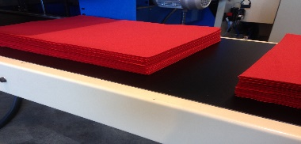

TEYMAN, S.L. Calle Alberic, 33 • 46610 GUADASSUAR (Valencia) Spain. www.teyman.com • teyman@teyman.com • phone: +34 96 141 23 07
07

